Setup instructions for Ubuntu

1. Install java 7:
sudo apt-get install openjdk-7-jdk

2. Install eXist db:
- Download eXist:
wget https://bintray.com/artifact/download/existdb/releases/eXist-db-setup-2.2.jar
- Install exist:
java -jar eXist-db-setup-2.2.jar
eXist window shows up. Follow all the steps till the installation of the database. Use admin as password when asked.
- Install eXist as a service (get in eXist's folder):
sudo bash tools/wrapper/bin/exist.sh install
In order to start/stop/restart eXist use: service eXist-db start|stop|restart
The default port of eXist is 8080. Change this port if needed.
In files:
- client.properties
- backup.properties
- index.html
- tools/jetty/etch/jetty.xml
change 8080 to your port number. For example 8090.
- Then, we need to fill our empty database with data. Run client.sh inside \bin folder:
sudo bash client.sh
eXist client shows up:
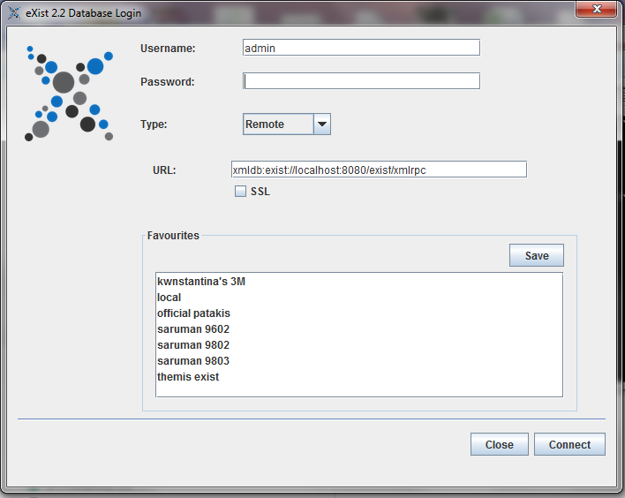
- Use admin as password and click Connect.
- Go to Tools->Restore and choose file 3MeXist-backup.zip to restore.
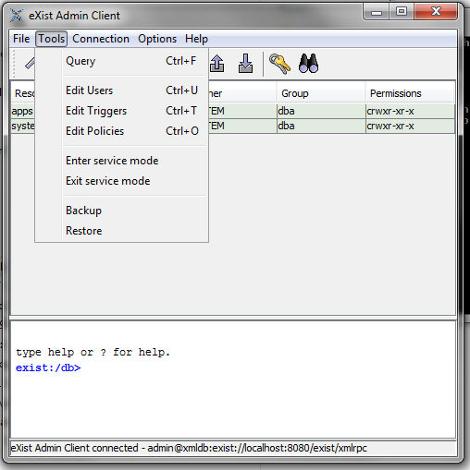
- If dialog asks for a password to restore, simply ignore it.

3. Install Tomcat:

- Install Tomcat7:
sudo apt-get install tomcat7-admin

- Install Tomcat as a service:
apt-get install tomcat7
Use service tomcat7 start/stop/restart

Change port number if needed. The default port is 8080. Edit /var/lib/tomcat7/conf/server.xml and change Connector port from 8080 to the port you wish. For example: 8084.

- Deploy webapps:
Copy 3M.war and 3MEditor.war to /webapps

4. Install configuration files:

Copy Projects folder in yours desired destination. Then, we must edit web.xml to point to the subfolders of this directory.
- Open web.xml inside var/lib/tomcat7/webapps/3M/WEB-INF and change the following values:
- schemaFolder: Change the path to point to the correct path at your local file system (where yours schema folder is located) .
- SystemUploads: Change the path to point to the correct path at your local file system (where yours uploads folder is located).
- Export_Import_Folder: Change the path to point to the correct path at your local file system (where yours export_import folder is located)
- Backups: Change the path to point to the correct path at your local file system (where yours Backups folder is located). Initially this folder is empty but when you create a System Backup from the system, the backup files are stored to this folder.

- Open web.xml inside var/lib/tomcat7/webapps/3MEditor/WEB-INF and change the following values:
- schemaFolder: Change the path to point to the correct path at your local file system (where yours schema folder is located) .
- uploadsFolder: Change the path to point to the correct path at your local file system (where yours uploads folder is located).

