**GRSF Knowledge Base Construction**

# Minimum Data Requirements

**Fisheries**

1. Fishery ID
2. Fishery name
3. Species
4. Fishing Area
5. Exploiting Stocks
6. Management Unit
7. Prod system type
8. Flag State
9. Fishing Gear
10. Annual Catch
11. DB Source
12. Source of Information
13. Ownership

**Stocks**

1. Stock /Assessment unit ID
2. Stock / Assessment unit name
3. Species
4. Fishing Area
5. Exploiting fishery
6. Management unit
7. Assessment methods
8. Scientific Advice
9. State of marine resource

* Exploitation rate
* Abundance level

1. DB Source
2. Source of information
3. Ownership

# FIRMS Case

**Fishery file used**: en_345.xml

**Stock file used:** en_7.xml

## Fishery ID

**xpath:** /fi:FIGISDoc/fi:Fishery/ fi:FisheryIdent/fi:FigisID

**example:** <fi:FigisID>345</fi:FigisID>

|  |
| --- |
| **Clarification** |
| It refers to the ID which is already given from FIRMS. It is NOT the generated unique identifier. |

## Fishery name

**xpath:** /fi:FIGISDoc/fi:Fishery/ fi:FisheryIdent/dc:Title

**example:** <dc:Title>Toothfish fishery - Eastern Ross Sea (Subarea 88.1)</dc:Title>

|  |
| --- |
| **Clarification** |
| OK |

## Species

**xpath:** /fi:FIGISDoc/fi:Fishery/fi:FishingIndustryActivity/fi:TargetSpecies/fi:SpeciesList/fi:SpeciesRef

/fi:FIGISDoc/fi:Fishery/fi:FishingIndustryActivity/fi:Bycatch/fi:SpeciesList/fi:SpeciesRef

**example:**

<fi:TargetSpecies>  
<fi:SpeciesList>  
<fi:SpeciesRef>  
<fi:FigisID MetaID="31005">2439</fi:FigisID>  
<dc:Title xml:lang="en">Patagonian toothfish</dc:Title>  
<fi:ForeignID Code="Dissostichus eleginoides" CodeSystem="scientific_name"/>  
<fi:ForeignID Code="TOP" CodeSystem="fao3alpha"/>  
</fi:SpeciesRef>  
<fi:SpeciesRef>  
<fi:FigisID MetaID="31005">2438</fi:FigisID>  
<dc:Title xml:lang="en">Antarctic toothfish</dc:Title>  
<fi:ForeignID Code="Dissostichus mawsoni" CodeSystem="scientific_name"/>  
<fi:ForeignID Code="TOA" CodeSystem="fao3alpha"/>  
</fi:SpeciesRef>  
 </fi:SpeciesList>  
</fi:TargetSpecies>

<fi:Bycatch Type="AssociatedSpecies">  
<fi:SpeciesList>  
<fi:SpeciesRef>  
<fi:FigisID MetaID="31005">16070</fi:FigisID>  
<dc:Title xml:lang="en">Grenadiers, rattails nei</dc:Title>  
<fi:ForeignID Code="Macrouridae" CodeSystem="scientific_name"/>  
<fi:ForeignID Code="RTX" CodeSystem="fao3alpha"/>  
</fi:SpeciesRef>  
<fi:SpeciesRef>  
<fi:FigisID MetaID="31005">2849</fi:FigisID>  
<fi:ForeignID Code="Rajidae" CodeSystem="scientific_name"/>  
<fi:ForeignID Code="RAJ" CodeSystem="fao3alpha"/>  
</fi:SpeciesRef>  
</fi:SpeciesList>  
</fi:Bycatch>

**Question 1:** Should we also include by_catch species?  
**Question 2:** dc:Title is the common name correct?

|  |
| --- |
| **Clarification** |
| Apart from the target species we should also include the associated species. In some cases the dc:title of a species might contain the common name (or refer to a genus or family). |

## Fishing Area

**xpath:** /fi:FIGISDoc/fi:Fishery/fi:FisheryIdent/fi:WaterAreaList

**example:**

<fi:WaterAreaList>  
<dc:Title>Eastern Ross Sea</dc:Title>  
<fi:WaterAreaRef>  
<fi:FigisID MetaID="22020">386</fi:FigisID>  
<dc:Title xml:lang="en">Pacific Antarctic / 88.1</dc:Title>  
<fi:ForeignID Code="88.1" CodeSystem="fao_sub_area"/>  
<fi:IntersectingAreas>  
<fi:WaterAreaRef>  
<fi:FigisID MetaID="22010">26</fi:FigisID>  
</fi:WaterAreaRef>  
</fi:IntersectingAreas>  
</fi:WaterAreaRef>

**Question 1:** Is this the fishing area element?  
**Question 2:** Should we include only the watearea mentioned in the dc:Title, the waterAreaRef, or should we include all the intersecting areas?

|  |
| --- |
| **Clarification** |
| The dc:title is a generic name of the fishing area. Although intersecting areas aren’t being used for identifying the record, they can be used for identifying similar records in other sources. |

## Exploiting Stocks

**xpath:** /fi:FIGISDoc/fi:Fishery/fi:FishingIndustryActivity/fi:RelatedAquaticResources/fi:AqResRef

**example:**

<fi:RelatedAquaticResources Type="Exploited">  
<fi:AqResRef>  
<fi:FigisID MetaID="195000">10526</fi:FigisID>  
<dc:Title xml:lang="en">Toothfish - Eastern Ross Sea</dc:Title>  
</fi:AqResRef>  
</fi:RelatedAquaticResources>

|  |
| --- |
| **Clarification** |
| OK. Although sometimes this information is not there. |

## Management Unit

**xpath:** /fi:FIGISDoc/fi:Fishery/fi:Management/fi:Jurisdiction/fi:ManagementEntity/fi:OrgRef

**example:** <dc:Title xml:lang="en">Commission for the Conservation of Antarctic Marine Living Resources (CCAMLR)</dc:Title>

**Question 1:** Is this enough?

|  |
| --- |
| **Clarification** |
| Apart from the name we also need the acronym.  In general for identifying the management unit the combination of the organization and the water area is needed, so we have to use the contents of the fi:GeoCoverage element |

## Prod system type

**xpath:** /fi:FIGISDoc/fi:Fishery/fi:FishingIndustryActivity/fi:TypeOfProductionSystem

**example:** <fi:TypeOfProductionSystem Value="Exploratory_fishery"/>

**Question 1:** What exactly is this?

|  |
| --- |
| **Clarification** |
| There are two main categories of production system types: (a) industrial fisheries where big missions with long vessel are exploited and (b) exploratory fisheries for smaller missions with small boats. |

## Flag State

**xpath:** -

**example:** -

|  |
| --- |
| **Clarification** |
| Flag state refers to the flag of the vessel (or vessels) operating the fisheries.  This piece of information is not always in a record.  Example record: <http://firms.fao.org/firms/fishery/970/en>  XPATH expression: /fi:FIGISDoc/fi:Fishery/fi:FishingIndustryActivity/fi:VesseltypeOverview/fi:FlagStateList |

## Fishing Gear

**xpath:** /fi:FIGISDoc/fi:Fishery/fi:FishingIndustryActivity/fi:VesseltypeOverview/fi:VesseltypeRef

**example:** <dc:Title xml:lang="en">Longliners</dc:Title>

**Question 1:** I did not find any equipment eg fishnets, is this ok? ( CatchHandlingProcEquip is BCData)

|  |
| --- |
| **Clarification** |
| XPATH expression: /fi:FIGISDoc/fi:Fishery/fi:FishingIndustryActivity/fi:GeartypeOverview /fi:FIGISDoc/fi:Fishery/fi:FishingIndustryActivity/fi:GeartypeOverview/fi:GeartypeRef |

## Annual Catch

**xpath:** /fi:FIGISDoc/fi:Fishery/fi:FishingIndustryActivity/fi:FisheryIndicatorList/fi:FisheryIndicator

**example:** <fi:FisheryIndicator Class="Exploitation" Measure="Catch" TimeFrame="2011" Type="Production" Unit="tonnes" Value="2839"/>

|  |
| --- |
| **Clarification** |
| XPATH expression: /fi:FIGISDoc/fi:Fishery/fi:FishingIndustryActivity/fi:FisheryIndicatorList/fi:FisheryIndicator  We need those with value (in the Measure attribute) either “Catch” (as the above example) or “Landed_Volume”, e.g. <fi:FisheryIndicator Class="Exploitation" Measure="Landed_Volume" TimeFrame="2014" Type="Production" Unit="tonnes" Value="2208.34"/> |

## DB Source

**xpath:** selection during input

**example:** FIRMS

|  |
| --- |
| **Clarification** |
| Apart from the title of the source, we will also need the URL of the actual record |

## Source of Information

**xpath:** /fi:FIGISDoc/fi:Fishery/fi:Sources/fi:BiblioEntry

**example:** <fi:BiblioEntry>Schedule of Conservation Measures in Force 2012/13 <dc:Identifier Type="URI">http://www.ccamlr.org/en/document/publications/schedule-conservation-measures-force-2012/13</dc:Identifier>  
</fi:BiblioEntry>

|  |
| --- |
| **Clarification** |
| It is the information that has been used for building the fact sheet. What we have is OK, however we should be careful since there might be more than one entries.  DO NOT confuse it with the bibliographic references. |

## Ownership

**xpath:** selection during input

**example:** FIRMS

**Question 1:** Will it be FIRMs for example or the specific data provider?

**Question 2:** Reference and reporting years are mentioned in the FIRMS concepts explanation xls under ownership. Why?

|  |
| --- |
| **Clarification** |
| The data owners are the data providers. They can be found under the element fi:CollectionRef. |

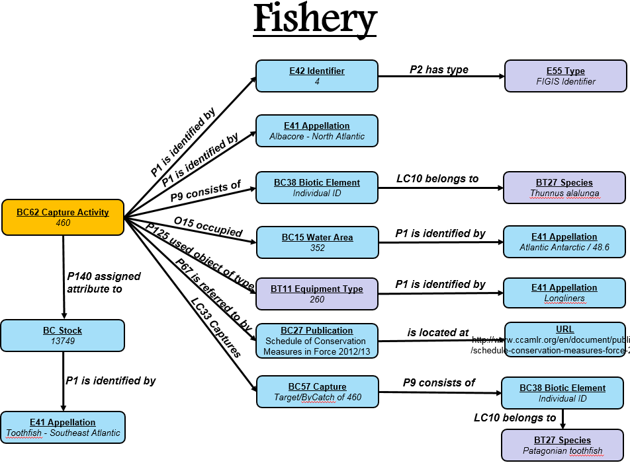

## Stock /Assessment unit ID

**xpath:** /fi:FIGISDoc/fi:AqRes/fi:AqResIdent/fi:FigisID

**example:** <fi:FigisID>7</fi:FigisID>

**Question 1:** How to distinguish stock from assessment unit? Couldn’t find the fields "Management unit" and "Considered a stock".

|  |
| --- |
| **Clarification** |
| If the attribute “BiologicalStock” of the element AqResStruct is true then this record is a stock. Otherwise (if the value of the attribute is false) it is a marine resource in general.  For the moment we do not need them so either we skip them, or model them in a different way. |

## Stock / Assessment unit name

**xpath:** /fi:FIGISDoc/fi:AqRes/fi:AqResIdent/dc:Title

**example:** <dc:Title>Albacore - South Atlantic</dc:Title>

|  |
| --- |
| **Clarification** |
| OK |

## Species

**xpath:** /fi:FIGISDoc/fi:AqRes/fi:AqResIdent/fi:SpeciesList/fi:SpeciesRef

**example:** <fi:SpeciesList>  
<fi:SpeciesRef>  
<fi:FigisID MetaID="31005">2496</fi:FigisID>  
<dc:Title xml:lang="en">Albacore</dc:Title>  
<fi:ForeignID Code="Thunnus alalunga" CodeSystem="scientific_name"/>  
<fi:ForeignID Code="ALB" CodeSystem="fao3alpha"/>  
<fi:Image Description="" Src="figis/species/images/Thunnus/sco_thu_ala_thu_62672.gif" Title="Species thumbnail" Use="Thumb"/>  
</fi:SpeciesRef>  
</fi:SpeciesList>

|  |
| --- |
| **Clarification** |
| OK |

## Fishing Area

**xpath:** /fi:FIGISDoc/fi:AqRes/fi:AqResIdent/fi:SpeciesList/fi:SpeciesRef

**example:** <fi:WaterAreaList>  
<fi:WaterAreaRef>  
<fi:FigisID MetaID="24323">3601</fi:FigisID>  
<dc:Title xml:lang="en">South Atlantic</dc:Title>  
<fi:ForeignID Code="ALB_S" CodeSystem="iccat_smu"/>  
<fi:IntersectingAreas>  
<fi:WaterAreaRef>  
<fi:FigisID MetaID="21005">5023</fi:FigisID>  
<dc:Title xml:lang="en">Agulhas Current</dc:Title>  
<fi:ForeignID Code="30" CodeSystem="lme"/>  
</fi:WaterAreaRef>  
<fi:WaterAreaRef>  
<fi:FigisID MetaID="22010">12</fi:FigisID>  
<dc:Title xml:lang="en">Atlantic, Eastern Central</dc:Title>  
<fi:ForeignID Code="34" CodeSystem="fao_major"/>  
</fi:WaterAreaRef>

**Question 1:** Is this the fishing area? Or just the wareareas that the species live in?

**Question 2:** Should we also include the intersecting areas??

|  |
| --- |
| **Clarification** |
| It is the stock monitoring area. |

## Exploiting fishery

**xpath:** ../fi:Exploit

**example:** -

**Question 1:** Clarification on the exploiting fishery CData.

|  |
| --- |
| **Clarification** |
| In some cases we do not have particular elements under fi:Exploit.  However in certain cases some proper elements exists that contain the appropriate information.  Example: <http://firms.fao.org/fishery/xml/resource/10511/en>  XPATH: /fi:FIGISDoc/fi:AqRes/fi:Exploit/fi:FisheryRef |

## Management unit

**xpath:** ../ fi:Management ?

**example:** -

**Question 1:** Clarification on the management CData. It is not in the same format with the fisheries management.

|  |
| --- |
| **Clarification** |
| Same as above (Exploiting Fisheriy) |

## Assessment methods

**xpath:** ../ fi:AssessModels?

**example:** -

**Question 1:** Clarification on the assessment method element.

|  |
| --- |
| **Clarification** |
| Use the dc:title of the element to denote the assessment model (described as assessment method in the minimum requirements) |

## Scientific Advice

**xpath:** ../fi: Advice?

**example:** -

**Question 1:** Clarification on the scientific advice element.

**Question 2:** What does it mean?

|  |
| --- |
| **Clarification** |
| Scientific advice comes from the institutions/organizations. In general there are two types of advices: (a) management advices and (b) scientific advices. For this concept we need the second type of advices.  Example: <http://firms.fao.org/fishery/xml/resource/10324/en>  XPATH: /fi:FIGISDoc/fi:AqRes/fi:BioAssess/fi:SciAdvice |

## State of marine resource

**xpath:** -

**example:** -

**Question 1:** Exploitation rate and abundance level cover this?

|  |
| --- |
| **Clarification** |
| XPATH: /fi:FIGISDoc/fi:AqRes/fi:AqResStateTrend |

## Exploitation rate

**xpath:** /fi:FIGISDoc/fi:AqRes/fi:AqResStateTrend/fi:ExploitRate

**example:** <fi:StandardExploitRate Value="High fishing mortality"/>

**Question 1:** ExploitRate or StandardExploitRate?

|  |
| --- |
| **Clarification** |
| ExploitRate: indicator from the provided by the owner  StandardExploitRate: standard indicator provided by a standard authority |

## Abundance level

**xpath:** /fi:FIGISDoc/fi:AqRes/fi:AqResStateTrend/fi:AbundanceLevel

**example:** <fi:StandardAbundanceLevel Value="Intermediate abundance "/>

**Question 1:** AbundanceLevel or StandardAbundanceLevel?

|  |
| --- |
| **Clarification** |
| Same as above (exploitation rate) |

## DB Source

**xpath:** selection during input

**example:** FIRMS

|  |
| --- |
| **Clarification** |
| Same as the DB Source element from Fisheries |

## Source of Information

**xpath:** /fi:FIGISDoc/fi:AqRes/fi:Sources/fi:BiblioEntry

**example:** <dc:Title>Albacore, Executive Summary. </dc:Title> Madrid, Spain September 30 - October 4 2013.

|  |
| --- |
| **Clarification** |
| Same as the Source of information element from Fisheries |

## Ownership

**xpath:** selection during input

**example:** FIRMS

**Question 1:** Will it be FIRMs for example or the specific data provider?

**Question 2:** Reference and reporting years are mentioned in the FIRMS concepts explanation xls under ownership. Why?

|  |
| --- |
| **Clarification** |
| Same as the Ownership element from Fisheries |

